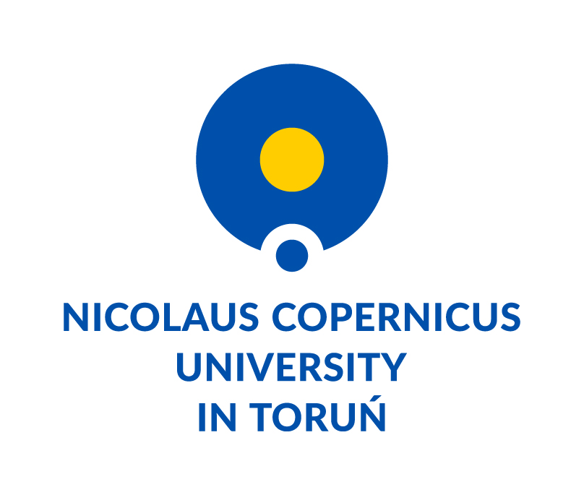 | ERASMUS+  Staff Mobility for Teaching (STA) + Staff Mobility for Training (STT)  CONFIRMATION | 

To whom it may concern

We herewith confirm that Ms/ Mr.
(title and name)

has taught hours in the framework of the ERASMUS+ Staff Mobility for Teaching combined with Staff Mobility for Training within Inter-Institutional Agreement signed between

Nicolaus Copernicus University in Toruń – PL TORUN01
(name of sending institution)

and

(name of receiving institution)

Confirmed duration of stay at the receiving university from ………. to ……….

(Signature and stamp of the receiving university)

